[Arti](https://doi.org/10.1016/j.aiig.2021.01.002)fi[cial Intelligence in Geosciences 1 (2020) 36](https://doi.org/10.1016/j.aiig.2021.01.002)–[51](https://doi.org/10.1016/j.aiig.2021.01.002)





Contents lists available at [ScienceDirect](http://www.sciencedirect.com/science/journal/26665441)

Artificial Intelligence in Geosciences

journal homepage: [www.keaipublishing.com/en/journals/artificial-intelligence-in-geosciences](http://www.keaipublishing.com/en/journals/artificial-intelligence-in-geosciences)

[](http://crossmark.crossref.org/dialog/?doi=10.1016/j.aiig.2021.01.002&domain=pdf)ShakeDaDO: A data collection combining earthquake building damage and ShakeMap parameters for Italy

Licia Faenza a,*, Alberto Michelini a, Helen Crowley b, Barbara Borzi b, Marta Faravelli b

a *INGV, Istituto Nazionale di Geofisica e Vulcanologia, Italy*

b *EUCENTRE, Centro Europeo di Formazione e Ricerca in Ingegneria Sismica, Italy*

A R T I C L E I N F O

*Keywords:* ShakeMap Building damage Italian earthquakes Data collection

A B S T R A C T

In this article, we present a new data collection that combines information about earthquake damage with seismic shaking. Starting from the Da.D.O. database, which provides information on the damage of individual buildings subjected to sequences of past earthquakes in Italy, we have generated ShakeMaps for all the events with magnitude greater than 5.0 that have contributed to these sequences. The sequences under examination are those of Irpinia 1980, Umbria Marche 1997, Pollino 1998, Molise 2002, L’Aquila 2009 and Emilia 2012. In this way, we were able to combine, for a total of the 117,695 buildings, the engineering parameters included in Da.D.O., but revised and reprocessed in this application, and the ground shaking data for six different variables (namely, in- tensity in MCS scale, PGA, PGV, SA at 0.3s, 1.0s and 3.0s). The potential applications of this data collection are innumerable: from recalibrating fragility curves to training machine learning models to quantifying earthquake damage. This data collection will be made available within Da.D.O., a platform of the Italian Department of Civil Protection, developed by EUCENTRE.

1. Introduction

This article describes the procedure implemented for the creation of a joint data collection of information on building damage and associated ground shaking (referred to herein as ShakeDaDO) for Italy. The main components used to develop this data collection are Da.D.O. (the Data- base of Observed Damage, Dolce et al., 2019) compiled by the Italian Civil Protection using damage assessment forms from sequences of past Italian earthquakes1 and the ground shaking provided by the new implementation of ShakeMap at INGV (Michelini et al., 2020). The data collection was developed in three consecutive steps. The first step involved the refinement of the information on buildings present in Da.D.O.. In the second step, we have recovered from the literature (or accessible web-services) the seismological information of the earth- quakes within Da.D.O. to calculate maps of ground shaking with the highest level of accuracy that is currently possible. The latest version of ShakeMap (version 4.0), which implements updated ground motion models and maps of local site corrections, was used for this purpose. Finally, each point of Da.D.O. was paired with the Mercal- li–Cancani–Sieberg intensity scale (MCS hereinafter), the ground shaking

parameters, the distance between the point under examination and the earthquake source, and the magnitude of the earthquake. The ground motion parameters of interest are: MCS intensity, peak ground acceler- ation, peak ground velocity, spectral acceleration at 0.3s, 1.0s and 3.0s, and their relative uncertainties. These six parameters are calculated by ShakeMap and were chosen because they give a comprehensive overview of shaking. In particular, these three spectral acceleration are chosen to display the amount of shaking experienced by structures sensitive to low periods, intermediate periods, and long periods.

The publication of the Da.D.O. database (Dolce et al., 2019) has made available a large amount of information on damage data of individual buildings from ten strong sequences of earthquakes that affected Italy since 1980. Around the same time, Michelini et al. (2020) published a new release of ShakeMap for the Italian territory. This implementation is based on the updated ShakeMap code architecture, which implements a new and more sophisticated strategy for the integration of real ground motion data and ground motion models (Worden et al., 2020). In addi- tion, it uses the latest ground motion models and an updated site effects map. Michelini et al. (2020) describe the new approach, quantify the consistency between recorded data and the resulting maps and compare

* Corresponding author.

*E-mail addresses:* [licia.faenza@ingv.it](mailto:licia.faenza@ingv.it) (L. Faenza), [alberto.michelini@ingv.it](mailto:alberto.michelini@ingv.it) (A. Michelini), [helen.crowley@eucentre.it](mailto:helen.crowley@eucentre.it) (H. Crowley), [barbara.borzi@eucentre.it](mailto:barbara.borzi@eucentre.it) (B. Borzi), [marta.faravelli@eucentre.it](mailto:marta.faravelli@eucentre.it) (M. Faravelli).

1 available at <http://egeos.eucentre.it/danno_osservato/web/danno_osservato>.

<https://doi.org/10.1016/j.aiig.2021.01.002>

Received 3 December 2020; Received in revised form 28 January 2021; Accepted 29 January 2021

Available online 11 February 2021

2666-5441/© 2021 The Authors. Publishing services by Elsevier B.V. on behalf of KeAi Communications Co. Ltd. This is an open access article under the CC BY-NC-ND license (<http://creativecommons.org/licenses/by-nc-nd/4.0/>).

Table 1

Number and properties of original and added (simulated) buildings in the Da.D.O. database.

|  |  |  |  |  |  |  |
| --- | --- | --- | --- | --- | --- | --- |
|  | Damage Grade | Structural Material | Buildings Added | Origial No. Buildings in Da.D.O. | Buildings Added | % of Original Buildings Added |
| Irpinia 1980 | DS0 | masonry | 163 | 38095 | 211 | 0.6% |
|  |  | RC 1 | 48 |  |  |  |
| Umbria-Marche | DS0 | masonry | 172 | 6980 | 1661 | 23.8% |
| 1997 |  | RC | 345 |  |  |  |
|  | DS1 | masonry | 270 |  |  |  |
|  |  | RC | 22 |  |  |  |
|  | DS2 | masonry | 137 |  |  |  |
|  | DS3 | RC | 2 |  |  |  |
|  |  | masonry | 307 |  |  |  |
|  | DS4 | RC | 2 |  |  |  |
|  |  | masonry | 141 |  |  |  |
|  | DS5 | RC | 1 |  |  |  |
|  |  | masonry | 262 |  |  |  |
| Pollino 1998 | DS0 | masonry | 313 | 3966 | 330 | 8.3% |
|  |  | RC | 6 |  |  |  |
|  | DS1 | masonry | 6 |  |  |  |
|  | DS2 | masonry | 1 |  |  |  |
|  |  | RC | 1 |  |  |  |
|  | DS3 | masonry | 2 |  |  |  |
|  | DS4 | masonry | 1 |  |  |  |
| Molise 2002 | DS0 | masonry | 789 | 14110 | 903 | 6.4% |
|  |  | RC | 110 |  |  |  |
|  | DS1 | RC | 4 |  |  |  |
| L’Aquila 2009 | DS0 | masonry | 519 | 52678 | 1597 | 3.0% |
|  |  | RC | 781 |  |  |  |
|  | DS1 | masonry | 102 |  |  |  |
|  |  | RC | 37 |  |  |  |
|  | DS2 | masonry | 55 |  |  |  |
|  |  | RC | 7 |  |  |  |
|  | DS3 | masonry | 59 |  |  |  |
|  |  | RC | 11 |  |  |  |
|  | DS4 | masonry | 14 |  |  |  |
|  |  | RC | 2 |  |  |  |
|  | DS5 | masonry | 7 |  |  |  |
|  |  | RC | 3 |  |  |  |
| Emilia 2012 | DS0 | masonry | 174 | 1866 | 335 | 17.9% |
|  |  | RC | 154 |  |  |  |
|  | DS1 | masonry | 2 |  |  |  |
|  | DS2 | masonry | 1 |  |  |  |
|  | DS3 | masonry | 1 |  |  |  |
|  | DS4 | masonry | 2 |  |  |  |
|  | DS5 | masonry | 1 |  |  |  |
| Totals |  |  |  | 117695 | 5037 | 4.3% |
| 1 reinforced concrete. |  |  |  |  |  |  |

the results obtained from the new configuration with the previous one that was fully described in Michelini et al. (2008).

In light of these developments, we have created a single data collec- tion that merges information about the damage and the characteristics of the individual buildings, with the associated ground shaking parameters inferred at the individual points provided by Da.D.O.. Combining these data and applications has allowed the construction of an extensive data collection, the first of its kind for Italy. Its application allows the impact of earthquakes to be addressed through new strategies, such as through the training of machine learning models.

The paper is divided into the following sections:

* refinement of the Da.D.O. database;

Table 2

List of the earthquakes with *M* ≥5.0 for the Irpinia 1980 sequence.

|  |  |  |  |
| --- | --- | --- | --- |
| Origin Time | Magnitude | Fault | Number of Stations |
| 1980-11-23 18:34:53 | 6.9 | Ameri et al. (2011) | 21 |
| 1980-11-24 00:24:00 | 5.0 | – | 4 |
| 1980-11-25 17:06:44 | 5.0 | – | 2 |

* creation of the ShakeMaps for all *M* ≥ 5.0 earthquakes belonging to each sequence under examination;
* assemblage of the ShakeDaDO data collection.

In the following, we describe the steps and reasoning that led to the

creation of the joint damage/ShakeMap data collection. We also present all of the maps that have been generated and a first statistical analysis of the data distribution.

1. Refinement of the Da.D.O. Database

The damage data in the Da.D.O. database, described in Dolce et al. (2019), required additional processing since it does not include all of the undamaged buildings (except for the Irpinia event which included all the buildings in the affected region). The Italian National Institute of Sta- tistics (ISTAT) census data from either the 1991, 2001 or 2011 census has been used to obtain an estimate of the total number of reinforced con- crete and masonry buildings in each municipality at the time of each event. Subsequently, the number of damaged buildings from Da.D.O. has been removed from the total number of buildings to provide an estimate of the number of undamaged buildings. It has not been possible to obtain

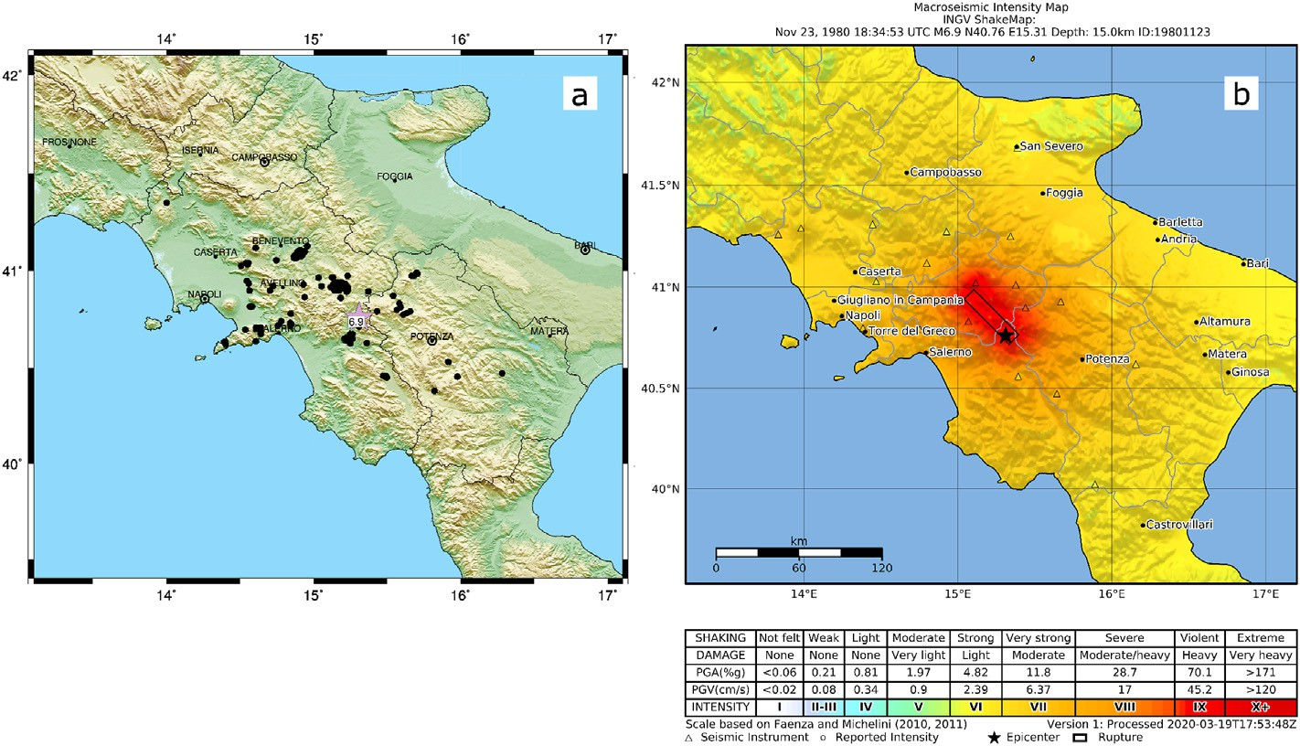

Fig. 1. November 23, 1980 Irpinia, M 6.9 earthquake. Panel *a*: Distribution of the Da.D.O. points; Panel *b*: ShakeMap for MCS intensity scale.

Table 3

List of the earthquakes with M ≥5.0 for the Umbria–Marche 1997 sequence.

Origin Time Magnitude Fault Number of

Stations

moderate damage (e.g., fall of large pieces of plaster); grade DS3 re- fers to heavy damage (e.g., large and extensive cracks in walls); grade DS4 refers to very heavy damage (e.g., serious failure of walls) and grade DS5 refers to destruction, the total collapse).

1997-09-26

00:33:11

1997-09-26

09:40:24

1997-10-03

08:55:20

1997-10-06

23:24:51

1997-10-12

11:08:35

1997-10-14

15:23:09

1998-03-21

16:45:09

1998-04-03

07:26:36

5.7 Hernandez et al. 15

(2004)

6.0 DISS (2010) 21

5.2 – 11

5.4 – 17

5.2 – 13

5.6 Hernandez et al. 28

(2004)

5.0 – 11

5.1 – 14

We also added an additional attribute representing the year in which the municipality first entered the seismic zonation classification. How- ever, it is noted that the calculation of undamaged buildings using Census data, as described above, adds a significant number of buildings for the DS0 class which are missing data on the location, number of floors, and age of construction. It was also found that there were also a few damaged buildings from the Da.D.O. database which lacked these attributes. To be able to complete these attributes for these buildings, we adopt the following strategy to generate the missing data: number of storeys and the age of construction are sampled on the basis of the frequency from the same municipality, as available in Da.D.O. database; the location is randomly sampled from the normalised density of population as avail- able in LandScan (2015). In the following the details of the points generated for each historical sequence is given, while in Table 1 a sum- mary is provided.

census data representing the building/dwelling statistics at the time of the Friuli 1976 and Abruzzo 1984 events, and so in these cases it has not been possible to estimate the undamaged buildings and they were thus excluded from further study. For the remaining eight sequences, only those municipalities where the inspection forms made up at least 80% of the estimated total number of buildings in the municipality have been considered in the calculations herein (as it cannot necessarily be assumed that municipalities with few damage forms had few damaged buildings). Due to a lack of municipalities that met this criterion, Emilia 2003 was also excluded from this study. As for the Garfagnana-Lunigiana 2013 earthquake, this earthquake was only recently included in Da.D.O. database. Six historical sequences of events in Italy have thus been analysed herein: Irpinia 1980, Umbria-Marche 1997, Pollino 1998, Molise 2002, L’Aquila 2009 and Emilia 2012. The following fields were extracted from the Da.D.O. database:

* location (latitude and longitude of the building);
* number of floors/storeys;
* age of construction;
* structure (masonry or reinforced concrete);
* damage (where the original damage descriptions in Da.D.O. were converted to DS0 to DS5 using the approach proposed by Dolce et al.

(2019), and where grade DS0 is for no damage; grade DS1 refers to slight damage (e.g., hair-line cracks in few walls); grade DS2 refers to

* 1. *Irpinia 1980*

The Da.D.O. database information on buildings for this earthquake belongs to 41 municipalities. Contrary to what happens for the data of the other sequences, for Irpinia the locations of all the buildings within Da.D.O. are placed at the coordinate of the town hall of the municipality of reference, since more detailed geographical information is not avail- able. To overcome this limitation, we have randomly distributed the buildings within the municipality using the same method described above for the buildings that were lacking location data. As before, the distribution was made on a probabilistic basis, using the population density available in LandScan (2015). For what concerns the buildings with missing data, these are all buildings with damage grade DS0 and they belong to 11 different municipalities; a total of 211 coordinates for these buildings have been simulated. Table S1 in the supplementary material summarises the information on all the buildings for which we have added missing attributes. The final database for Irpinia 1980 is composed of 38,095 data points.

* 1. *Umbria*–*Marche 1997*

The Da.D.O. database data for this earthquake belong to 12 munici- palities. For the buildings with missing attributes, these belong to 12

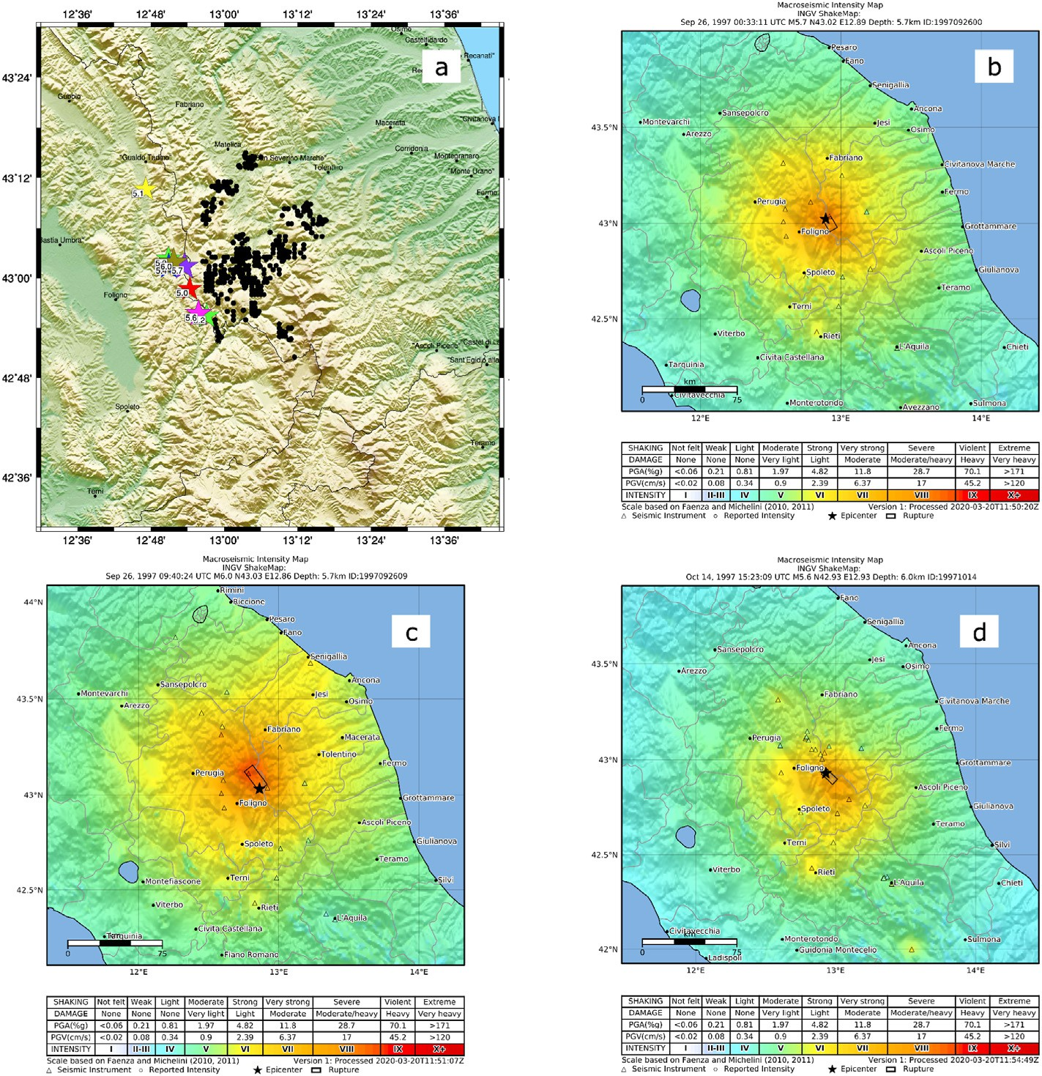

Fig. 2. Umbria-Marche 1997 earthquake sequence. Panel *a*: data points (solid black circles) and earthquakes (stars) with *M* ≥ 5.0. Panel *b*: ShakeMap for the first September 26, 1997 Umbria-Marche earthquake in MCS intensity scale. Panel *c*: ShakeMap for the second September 26, 1997 Umbria-Marche earthquake in MCS

intensity scale. Panel *d*: ShakeMap for the October 14, 1997 Umbria-Marche earthquake in MCS intensity scale.

Table 4

List of the earthquake with M ≥ 5.0 for the Pollino 1998 sequence.

|  |  |  |  |
| --- | --- | --- | --- |
| Origin Time | Magnitude | Fault | Number of Stations |
| 1998-09-09 11:28:00 | 5.6 | – | 5 |

different municipalities, and 1661 coordinates have been simulated. Table S2 in the supplementary material summarises the information on all the buildings for which we have added missing attributes. For this event there are some municipalities for which buildings with damage grades other than DS0 have also been generated, such as Fiastra, Monte Cavallo and Pieve Torina; the type of structure of the simulated buildings are mainly reinforced concrete for damage grade DS0, and masonry for the other damage states. The final database for Umbria-Marche 1997 is composed of 6980 data points.

* 1. *Pollino 1998*

The Da.D.O. database data for this earthquake belong to 6 munici- palities. The buildings with missing attributes belong to 6 different mu- nicipalities, and 330 coordinates have been randomly simulated. Table S3 in the supplementary material summarises the information on all the buildings for which we have added missing attributes, which are mainly masonry buildings with damage grade DS0. The final database for Pollino 1998 is composed of 3966 data points.

* 1. *Molise 2002*

The Da.D.O. database data for this earthquake belong to 16 munici- palities. The buildings whose attributes have been simulated belong to 13 different municipalities, and a total of 903 coordinates have been simulated. Table S4 in the supplementary material summarises the in- formation on all the buildings for which we have added missing attri- butes. As for Pollino 1998, the majority of simulated buildings are masonry with no damage (DS0). The final database for Molise 2002 is composed of 14,111 data points.

* 1. *L*’*Aquila 2009*

The Da.D.O. database data for this earthquake belong to 38 munici- palities. The buildings with missing attributes belong to 32 different municipalities, and a total of 1597 coordinates have been simulated. Table S5 in the supplementary material summarises the information on all the buildings for which we have added missing attributes. As for Umbria–Marche 1997, for this earthquake, the simulation of buildings not only includes those belonging to the DS0 class but also some of the other categories. The municipalities of Castel del Mare, Pietracamela and Calascio showed this behaviour. In the regional capital, L’Aquila, the damage grade with by far the largest number of buildings to simulate is DS0, with a reinforced concrete structure type. Contrary to other earth- quakes, several points belonging to class DS1 have also been simulated. The final database for L’Aquila 2009 is composed of 52,679 data points.

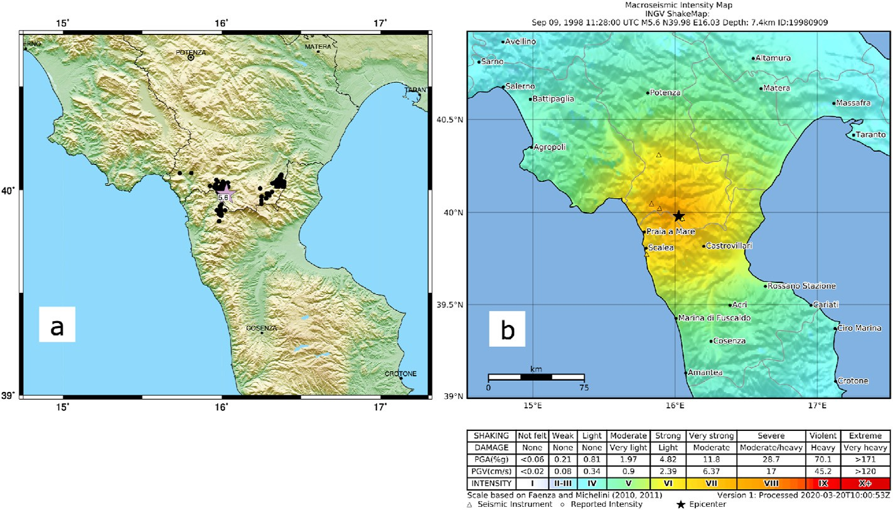

Fig. 3. September 9, 1998 Pollino, M 5.6 earthquake. Panel *a*: Distribution of the Da.D.O. points; Panel *b*: ShakeMap for MCS intensity scale.

Table 5

List of the earthquakes with *M* ≥ 5.0 for the Molise 2002 sequence.

Origin Time Magnitude Fault Number of Stations

2002-10-31 10:33:00 5.7 DISS (2010) 11

2002-11-01 15:09:02 5.7 DISS (2010) 10

* 1. *Emilia 2012*

The Da.D.O. database data for this earthquake belong to just 2 mu- nicipalities. The buildings with missing attributes belong to both mu- nicipalities, and 335 coordinates have been randomly simulated. Table S6 in the supplementary material summarises the information on all the buildings for which we have added missing attributes. The main damage grade of buildings with missing attributes is DS0, in equal part of structure type masonry and reinforced concrete; only a very limited number of buildings in other damage grade is simulated. The final database for Emilia 2012 is composed of 1866 data points.

1. ShakeMaps

This section describes the generation of the ground shaking maps to be associated with the historical sequences in the Da.D.O. database. Some of the sequences that are of interest for this study are complex, consisting

of several earthquakes with comparable magnitudes, and which are spatially very extended. This characteristic could influence the shaking suffered by the different zones where buildings are located. We have therefore calculated all the ShakeMaps related to events with magnitude

*M* ≥ 5.0, which occurred during the whole sequence, and not just those

associated to the mainshock. For the seismological information, we used

the Engineering Strong-Motion (ESM) database (Luzi et al., 2016). The ESM website gives the possibility to download through a web service the peak values of the ground motion parameters in a format suitable for ShakeMap. The ground motion variables we considered are macroseismic intensity in MCS scale, PGA, PGV, SA 0.3s, SA 1.0s and SA 3.0s. More- over, ESM gives the possibility to download the extended fault if it is

Table 6

List of the earthquakes with *M* ≥ 5.0 for the L’Aquila 2009 sequence.

|  |  |  |  |
| --- | --- | --- | --- |
| Origin Time | Magnitude | Fault | Number of Stations |
| 2009-04-06 01:32:40 | 6.1 | Ameri et al. (2012) | 62 |
| 2009-04-06 02:37:04 | 5.1 | – | 18 |
| 2009-04-06 23:15:36 | 5.1 | – | 23 |
| 2009-04-07 09:26:28 | 5.1 | – | 26 |
| 2009-04-07 17:47:37 | 5.5 | Galloviˇc et al. (2014) | 56 |
| 2009-04-09 00:52:59 | 5.4 | – | 50 |
| 2009-04-09 19:38:16 | 5.2 | – | 44 |
| 2009-04-13 21:14:24 | 5.0 | – | 48 |

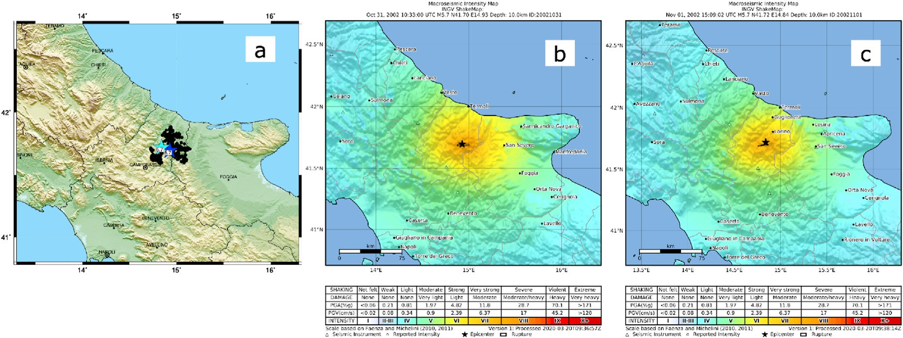

Fig. 4. Molise 2002 earthquake sequence. Panel *a*: data points (solid black circles) and earthquakes (stars) with *M* ≥ 5.0. Panel *b*: ShakeMap for the October 31, 2002 Molise earthquake in MCS intensity scale. Panel *c*: ShakeMap for the November 1, 2002 Molise earthquake in MCS intensity scale.

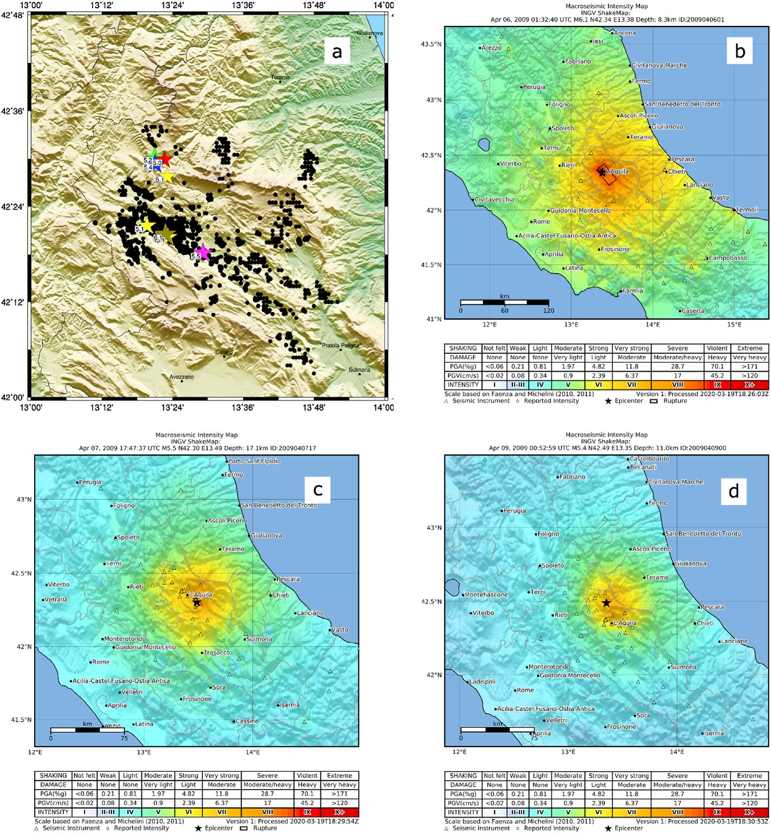

Fig. 5. L’Aquila earthquake sequence. Panel *a*: data points (solid black circles) and earthquakes (stars) with *M* ≥ 5.0. Panel *b*: ShakeMap for the April 6, 2009 L’Aquila earthquake, in MCS intensity scale. Panel *c*: ShakeMap for the April 7, 2009 L’Aquila earthquake in MCS intensity scale. Panel *d*: ShakeMap for the April 9, 2009

L’Aquila earthquake in MCS intensity scale.

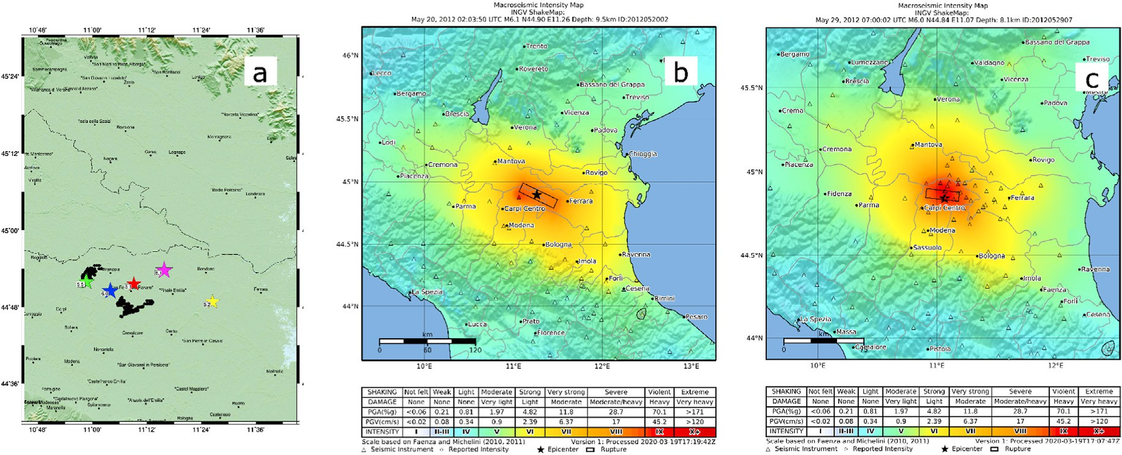

Fig. 6. Emilia 2012 earthquake sequence. Panel *a*: data points (solid black circles) and earthquakes (stars) with *M* ≥ 5.0. Panel *b*: ShakeMap for the May 20, 2010 Emilia earthquake in MCS intensity scale. Panel *c*: ShakeMap for the May 29, 2010 Emilia earthquake in MCS intensity scale.

available in the literature. For stronger earthquakes, there are several solutions for the extended fault in the literature, and it is not always straightforward to define which is the best choice. In ShakeMap appli- cations, the extended fault has an impact on the magnitude and shape of

shaking, especially in the near field. This work has decided to select the input data for the ShakeMap calculation from a single database (ESM). In this way, we have aligned ourselves with the choice made in ESM for the extended fault associated with the earthquake.

Table 7

List of the earthquakes with *M* ≥ 5.0 for the Emilia 2012 sequence.

|  |  |  |  |
| --- | --- | --- | --- |
| Origin Time | Magnitude | Fault | Number of Stations |
| 2012-05-20 02:03:50 | 6.1 | Pezzo et al. (2013) | 270 |
| 2012-05-20 03:02:47 | 5.1 | – | 125 |
| 2012-05-20 13:18:01 | 5.2 | – | 96 |
| 2012-05-29 07:00:02 | 6.0 | Paolucci et al. (2015) | 280 |
| 2012-05-29 10:55:56 | 5.5 | Pondrelli (2002) | 198 |
| 2012-05-29 11:00:22 | 5.5 | Ekstro€m et al. (2012) | 71 |

Table 8

List of the parameters in ShakeDaDO data collection.

Parameters

Earthquake Identifier Number of Storeys

Average Year of Construction Structural Material

Year of Seismic Classification of the Municipality classification-age of construction code as:

1. building constructed before the seismic regulations;
2. building constructed after the seismic regulations;
3. building constructed after 2000;

Vs,30

Damage Grade MCS max

Uncertainty of MCS max

Distances between earthquake and Da.D.O. datapoint for the MCS couple Distance Code (*RJB* 1 if the fault is available, *Repi* 2 otherwise) for the MCS couple Magnitude for the MCS couple

PGA max [*ln*(*g*)]

Uncertaintyof PGA max [*ln*(*g*)]

Distances between earthquake and Da.D.O. datapoint for PGA couple

Distance Code (*RJB* if the fault is available, *Repi* otherwise) for PGA couple Magnitude for PGA couple

PGV max [*ln*(*cm* /*s*)]

Uncertainty of PGV max [*ln*(*cm* /*s*)]

Distances between earthquake and Da.D.O. datapoint for PGV couple

Distance Code (*RJB* if the fault is available, *Repi* otherwise) for PGV couple Magnitude for PGV couple

SA 0.3s max [*ln*(*g*)]

Uncertainty of SA 0.3s max [*ln*(*g*)]

Distances between earthquake and Da.D.O. datapoint for SA 0.3s couple

Distance Code (*RJB* if the fault is available, *Repi* otherwise) for SA 0.3s couple Magnitude for SA 0.3s couple

SA 1.0s max [*ln*(*g*)]

Uncertainty of SA 1.0s max [*ln*(*g*)]

Distances between earthquake and Da.D.O. datapoint for SA 1.0s couple

Distance Code (*RJB* if the fault is available, *Repi* otherwise) for SA 1.0s couple Magnitude for SA 1.0s couple

SA 3.0s max [*ln*(*g*)]

Uncertainty of SA 3.0s max [*ln*(*g*)]

Distances between earthquake and Da.D.O. datapoint for SA 3.0s couple

Distance Code (*RJB* if the fault is available, *Repi* otherwise) for SA 3.0s couple Magnitude for SA 3.0s couple

1 *RJB* is distance to the surface projection of the rupture.

2 *Repi* is the epicentral distance.

Michelini et al. (2020) describe the adopted ground motion models and the new map of *VS*30 for the site effects. The software implemented is the ShakeMap version 4.0 (Worden et al., 2020). Below we describe the main features of the earthquakes we have considered and show the most relevant ShakeMaps that have been calculated.

* 1. *ShakeMaps for Irpinia 1980*

There are 3 earthquakes with a magnitude greater than 5.0 for this sequence, as shown in Table 2, with information on location, magnitude, fault and number of stations available. Only for the first earthquake, the one with the larger magnitude, the extended fault model is available. Also, for this earthquake, 21 stations have recorded the ground motion, while for the other two earthquakes only few stations recorded the event.

Logically, the considerable difference in magnitude between the first earthquake and the other two implies that the main earthquake with magnitude M 6.9 is responsible for the damage reported in the Da.D.O. database. Fig. 1 instead shows the distribution of the Da.D.O. points on panel *a*, while in panel *b* the ShakeMaps in MCS intensity of the main earthquake. Figure S1 in the supplementary material shows the Shake- Maps for all the ground motion values. The 1980 Irpinia earthquake was undoubtedly the most devastating earthquake in Italy since the Second World War. According to the most reliable estimates, it caused about 280,000 displaced people, about 9000 injured and 3000 dead. The earthquake affected three regions, Campania, Basilicata and Puglia, with an area aligned along fault strike longer than 60 km featuring MCS in- tensity higher than IX.

* 1. *ShakeMaps for Umbria*–*Marche 1997*

The seismic sequence of Umbria–Marche 1997, which affected parts of the two regions of central Italy, began in September 1997 and ended in March 1998. On September 26 in the night, there was the first of the three main earthquakes (M 5.7), while in the late morning of the same day there was the second earthquake (M 6.0). This second event was responsible for the fall of the Giotto and Cimabue vault in the Basilica of St. Francis in Assisi, which killed four people. The third main event (M 5.6) on October 14 caused the lantern in the Town Hall of Foligno to collapse. Overall, there are 8 earthquakes with magnitude greater than

5.0 that have occurred in the time span September 1997 to April 1998, as shown in Table 3.

A fault model is available for the three larger earthquakes. The number of stations that have recorded the earthquakes changes consid- erably during the sequence. In fact, after the September 26, several other stations belonging to temporary networks were installed, which allowed for a good coverage of the near field for the 1 October 14 earthquake.

Fig. 2, panel *a*, shows the spatial distribution of earthquakes and the points of the Da.D.O. database. As can be seen from the figure, the points of the Da.D.O. database fall all in the Marche region. An important thing to observe in the figure is that there are some points in the database that are very close to the third largest event of the sequence (M 5.6 occurred on October 14, 1997, pink star in Fig. 2, panel *a*) to the south, whereas other Da.D.O. points are affected by the earthquakes of September 26, 1997, M 6.0 and M 5.7, dark green and violet stars in Fig. 2, panel *a*. Fig. 2, panels *b,c,d*, shows the ShakeMap for the 3 mainshocks of the sequence, in MCS intensity scale. Figures S2, S3, S4 in the supplementary material show the ShakeMaps for all the ground motion values. From the three figures, it is possible to notice that the second earthquake on September 26 (M6.0) caused the most damage in area located northern respect to the epicentres, with values of macroseismic intensity in the epicentral zone corresponding to grade IX of the MCS scale. The area in which the effects of the earthquake equal to grade VIII-IX is 20 km long, along the north-west direction of the fault. The third earthquake (M 5.6) which occurred further south, on the other hand, shows an extended area of several km where the macroseismic intensity reaches grade VIII. The same area in previous earthquakes had shown macroseismic intensity equal to degree VI-VII on the MCS scale.

* 1. *ShakeMaps for Pollino 1998*

The sequence relating to the earthquake that struck Calabria in 1998 has only one earthquake with a magnitude greater than 5.0. Table 4 summarises the characteristics of this earthquake. No extended fault model is available for this earthquake of moderate size; it was only registered by 5 stations.

Fig. 3 instead shows the distribution of the Da.D.O. points on panel *a*, while on panel *b* the ShakeMap in MCS intensity. Figure S5 in the sup- plementary material shows the ShakeMaps for all the ground motion values. The area of Pollino, in Calabria, has already been the scene of significant earthquakes in the past. The epicentre is located between the

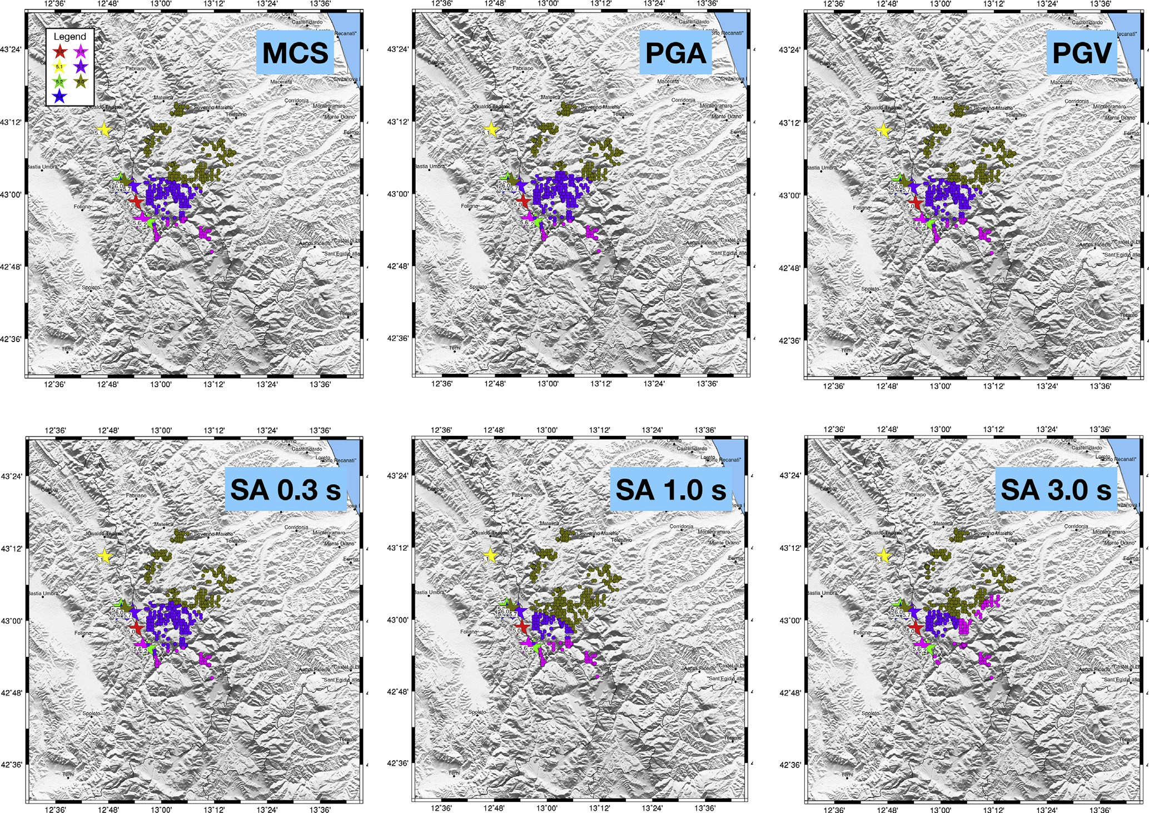

Fig. 7. Association of the Da.D.O. points to the earthquakes ground shaking for the Umbria–Marche 1997. Stars: earthquakes (coloured according to the legend in panel *a*), dots: points in Da.D.O. database. The color of the dots indicates which earthquake the dot has been coupled with, for MCS (Panel *a*), PGA (Panel *b*), PGV (Panel *c*), SA 0.3s (Panel *d*), SA 1.0s (Panel *e*), SA 3.0s (Panel *f*).

municipalities of Castelluccio Inferiore, Castelluccio Superiore and Lau- ria. The epicentre zone shows macroseismic intensity values equal to grade VII-VIII of the MCS scale.

* 1. *ShakeMaps for Molise 2002*

The earthquakes with magnitude greater than 5.0 that occurred during the seismic sequence of 2002 in Molise are two they are close both spatially and temporally and also have the same magnitude. Table 5 summarises the characteristics of these earthquakes. Also in this case, as with the 1998 Pollino earthquake, not many stations recorded the earthquakes. The faults are available for both earthquakes and come from the DISS (2010) and 10 stations recorded the events, but in both cases, they are located far from the epicenters. The earthquake of Molise in 2002 is composed of two earthquakes of the same size that occurred between October 31 and November 1, 2002, with the epicentre located in the province of Campobasso, between the towns of San Giuliano di Puglia, Colletorto, Santa Croce di Magliano, Bonefro, Castellino del Biferno and Provvidenti.

Fig. 4 instead shows the distribution of the Da.D.O. points on panel *a*, while the ShakeMap related to these earthquakes in MCS intensity scale are presented on panels *b* and *c*. Figures S6 and S7 in the supplementary material show the ShakeMaps for all the ground motion values for these two earthquakes. In the first event, the effects of the earthquake reached a value equal to grade VIII on the MCS scale, while they were slightly lower for the second event.

* 1. *ShakeMaps for L*’*Aquila 2009*

There are 8 earthquakes with a magnitude greater than 5.0 that have occurred during this sequence, and they all occurred in the time span from April 6 to April 13, 2009. Table 6 shows the main data underlying ShakeMap. Comparing the number of recorded data with those of the previous events, it is clear that the number of stations has increased. After the first earthquake, as happens when a damaging earthquake occurs, INGV and other research institutes and universities have installed many stations in the epicentre area. In this way, we can generate more con- strained ShakeMaps in the epicentral area. It should be noted that the higher number of stations in the first earthquake depends on the fact that the ShakeMap for earthquakes with magnitude greater than 6 is more spatially extended than the others.

The main shock, which occurred on April 6, 2009, was felt throughout central-southern Italy. This event is currently the most severe earth- quake, in terms of the number of victims and damage, of the 21st century in Italy. Also, in the city of L’Aquila, several strategic buildings, such as the Prefect’s Office, the Regional Hospital, the headquarters of the Uni- versity, the Police Headquarters and the Student House suffered severe damage. The city of L’Aquila and the entire basin of L’Aquila, since the fourteenth century, has always been subject to earthquakes of severe or medium intensity. Three other significant earthquakes struck the area, all with a macroseismic intensity value equal to the grade IX of the MCS scale. Fig. 5 panel *a*, shows the distribution of the different earthquakes with respect to the points of the Da.D.O. database. The important thing to

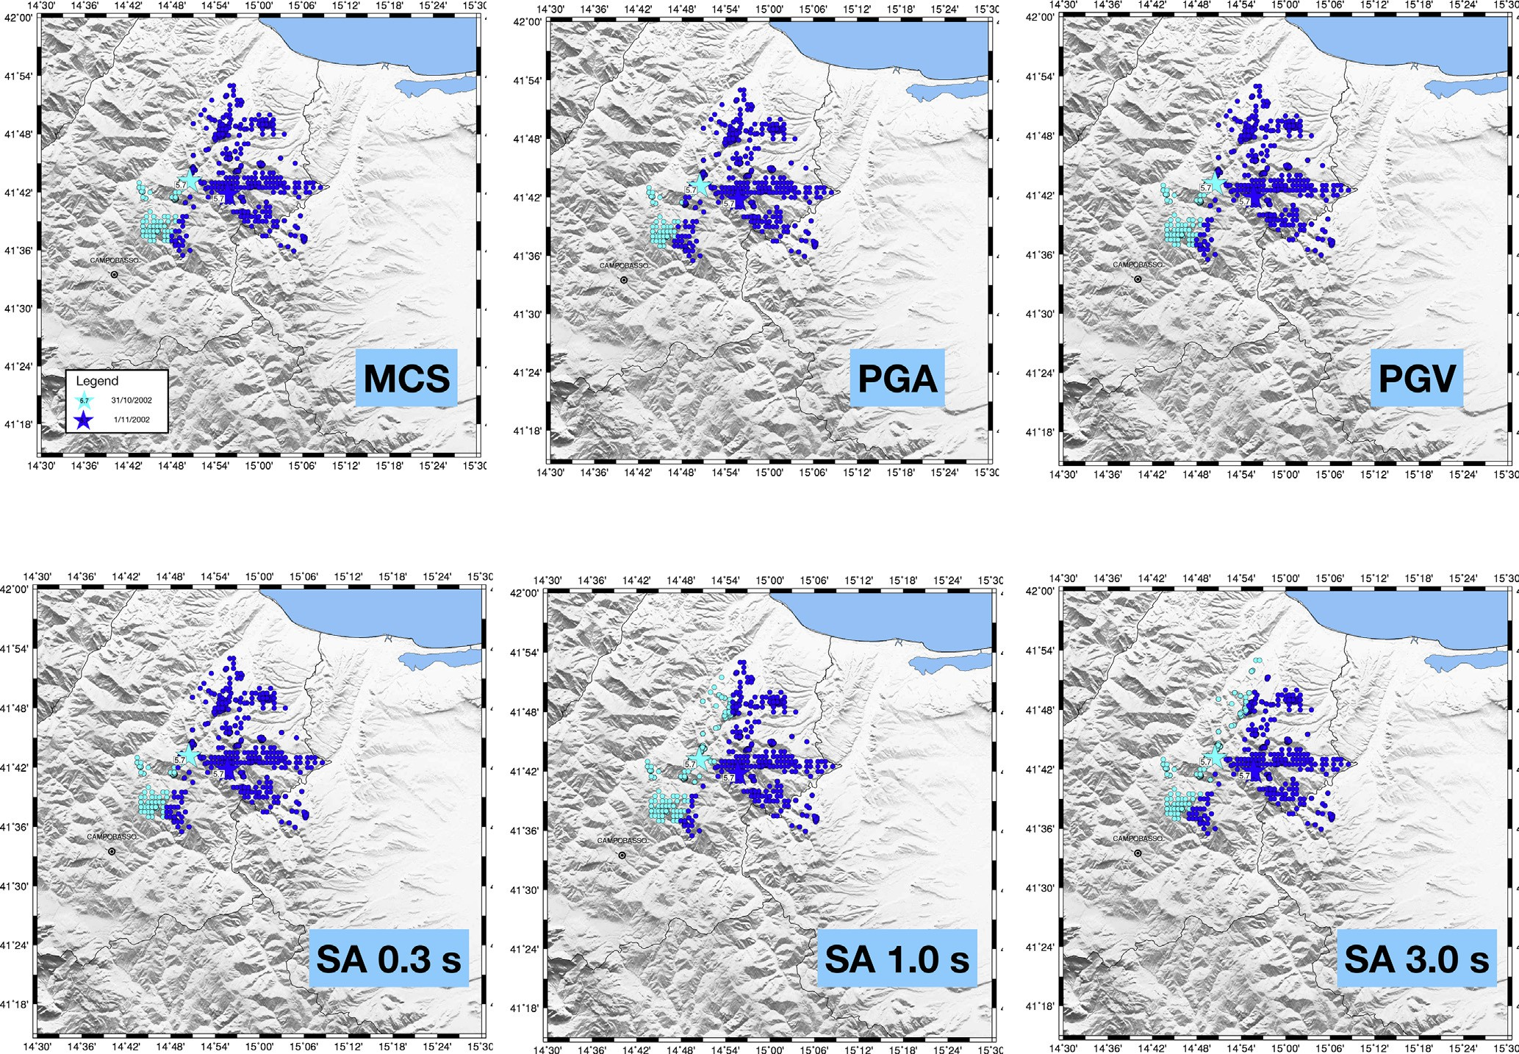

Fig. 8. Association of the Da.D.O. points to the earthquakes ground shaking for the Molise 2002. Stars: earthquakes (coloured according to the legend in panel *a*), dots: points in Da.D.O. database. The color of the dots indicates which earthquake the dot has been coupled with, for MCS (Panel *a*), PGA (Panel *b*), PGV (Panel *c*), SA 0.3s (Panel *d*), SA 1.0s (Panel *e*), SA 3.0s (Panel *f*).

note in the figure is that there are several earthquakes north of L’Aquila, near the Campotosto, with a maximum magnitude of M 5.4 that could affect the damage to the buildings located in the northern area. We show as an example the maps for 3 earthquakes in the sequence. The first one is for the mainshock M 6.1 of April 6, 2009 (Fig. 5, panel *b*). The maximum macroseismic intensity reaches the values of IX of MCS scale, in the di- rection south-east for the city of L’Aquila. The village of Onna, located in this area, was destroyed. The second one shows the shaking related to the earthquake M 5.5 of April 7, which affected the southernmost part of the aftershock area (Fig. 5, panel *c*), with a maximum of macroseismic in- tensity equal to VIII of MCS intensity. Finally, the ShakeMap of the earthquake with M 5.4 of April 9, 2009 is presented, which occurred in the northernmost part of the area affected by the sequence (Fig. 5, panel *d*). The epicentral area of this earthquake suffers a macroseismic intensity equals to grade VIII of MCS scale. Figures S8, S9, S10 in the supple- mentary material show the ShakeMaps for all the ground motion values.

* 1. *ShakeMaps for Emilia 2012*

The sequence that hit the Emilia region in 2012 had two main shocks of comparable magnitude but quite distant spatially, and several other earthquakes with magnitude greater than 5.0 (see Fig. 6, panel *a*). The seismic sequence has affected the Po Valley region, an area where strong earthquakes occur at medium-low frequency. But historical information has shown that already in the past earthquakes had happened in the area, as in 1579 (M 5.4) with a maximum macroseismic intensity equal to grade VIII and 1639 (M 5.3) with a maximum intensity equal to grade VII-VIII of the MCS scale.

Table 7 and Fig. 6 show an overview of the data used to calculate the ShakeMap and the spatial distribution of the epicentres of the earth- quakes with respect to points in the Da.D.O. database. For this sequence, we use the extended source for four out of six earthquakes. The number of stations we have at our disposal is significantly higher than those of earthquakes that occurred several years ago. Moreover, after the first earthquake of the sequence, we notice an improvement in the station coverage in the epicentral area, allowing a better constraint of the shaking. The earthquakes caused massive damage to rural and industrial buildings, water pipelines, historical buildings and monuments and old stone buildings. The most damaged provinces are those of Modena and Ferrara, where the territory affected has an area of about 1800 square kilometres. We show as an example the maps in MCS intensity scale for 2 earthquakes in the sequence, related to the strongest earthquakes in the sequence (Fig. 6 panels *b* and *c*), while Figures S11 and S12 in the sup- plementary material show the ShakeMaps for all the ground motion values.

1. Preparation of the damage and ground motion data collection

The last step in developing ShakeDaDO data collection consists of associating the building damage to the level of the ground shaking experienced at the same location, defined by the coordinates in the processed version of the Da.D.O. database described in Section 2, to produce the ShakeDaDO data collection. To this end, we have imple- mented the following strategy. For each point of the Da.D.O. database, we have associated the maximum shaking that occurred during the whole sequence as determined by the calculated ShakeMaps, as described in

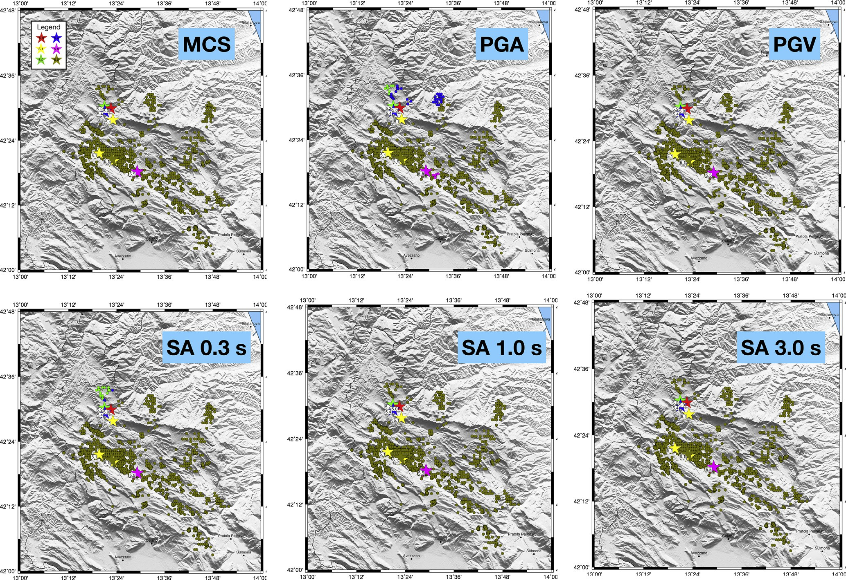

Fig. 9. Association of the Da.D.O. points to the earthquakes ground shaking for the L’Aquila 2009. Stars: earthquakes (coloured according to the legend in panel *a*), dots: points in Da.D.O. database. The color of the dots indicates which earthquake the dot has been coupled with, for MCS (Panel *a*), PGA (Panel *b*), PGV (Panel *c*), SA 0.3s (Panel *d*), SA 1.0s (Panel *e*), SA 3.0s (Panel *f*).

Section 3. In this way, we have tried to take into account the occurrence of several earthquakes in close time and space. The six variables quan- tifying the ground shaking are treated separately and independently of each other. This choice implies that, for example, the same Da.D.O. point may have the maximum shaking for the PGA ground value that is asso- ciated with an earthquake from the sequence that is different to the earthquake leading to the maximum PGV. Each ground motion variable is associated with the epicentral distance and the magnitude. It is to be noted that the new ShakeMap configuration (Worden et al., 2020) allows for the calculation of the ground motion values directly at the sought target point. The shaking value is also associated with the uncertainty, as specified in Worden et al. (2018). Finally, each building contained in the Da.D.O. database is associated with the damage grade description, as available in Da.D.O. database (Dolce et al., 2019) and described in sec- tion 2, and the maximum ground shaking values of the six shaking pa- rameters as derived from the largest events of the sequence. Whilst it would have been very useful to use the date of damage evaluation in the ShakeDaDo data collection (to ensure that all of the main events pre- ceding the damage were included), this data is not publicly available within Da.D.O.. Typically, damage surveys for large numbers of buildings can take weeks to complete, and so it was felt to be appropriate to include all the ground shaking from the potentially damaging aftershocks in the days following the main event. The only event for which a wider range of time has been considered is the Umbria-Marche sequence, which occurred over a period of 6 months. The damage data is likely to have been collected following each of the large events in this sequence, but as mentioned previously, the actual damage survey date for each building in the Da.D.O. database is not available.

Table 8 provides the final list of parameters in the ShakeDaDO data collection, where for reasons of privacy the actual location in terms of latitude and longitude is not provided.

It is noted that for the Irpinia 1980 and Pollino 1998 earthquakes there is only one earthquake responsible for the damage. For the sequence relating to Emilia 2012, the earthquake with magnitude 6.1 on May 20 is too far from the points in the Da.D.O. database compared to the other strong earthquake in the sequence, which occurred on May 29 (see Fig. 6). This spatial distribution implies that the Da.D.O. points, for all the ground motion variables, are associated with the May 29 earthquake. For the other four sequences the situation is not linear, and is described in more detail in the following sections.

* 1. *Umbria*–*Marche 1977 data collection*

The sequence under examination consists of several earthquakes. Fig. 7 shows which earthquakes the different points of the Da.D.O. database are associated with, for the 6 ground shaking variables.

The MCS parameter (panel *a* in Fig. 7) shows that the Da.D.O. points to the north are associated with the shaking caused by the earthquake with largest magnitude (M 6.0 of September 26, 1997), the dark green points in the Figure. In purple there are highlighted the Da.D.O. points associated with the first earthquake with M 5.7 that also occurred on September 26, 1997. While the pink points further south are associated with the October 14, 1997, M 5.6 shock. The association of the Da.D.O. points concerning the different earthquakes in the sequence is substan- tially the same for the other ground motion variables, with the exception of SA 3.0s. In this case, the earthquake of October 14, 1997 M 5.6 has

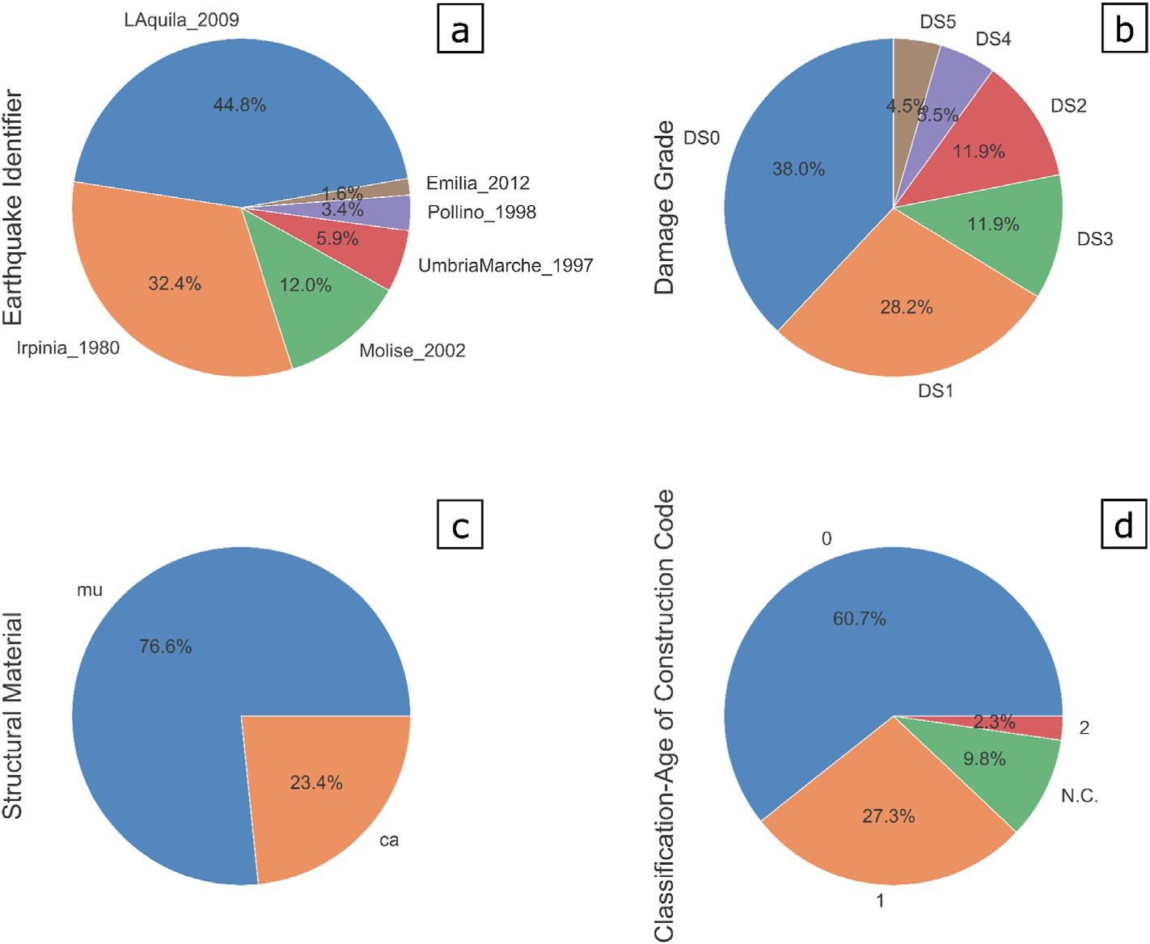

Fig. 10. Distribution of the different categories in the ShakeDaDO data collection. Panel *a*: Earthquake Identifier; Panel *b*: Damage Grade; Panel *c*: Structural Material; Panel *d*: Classification-Age of Construction Code. “N.C.” (Not compiled) implies that no information was available for that building in this category.

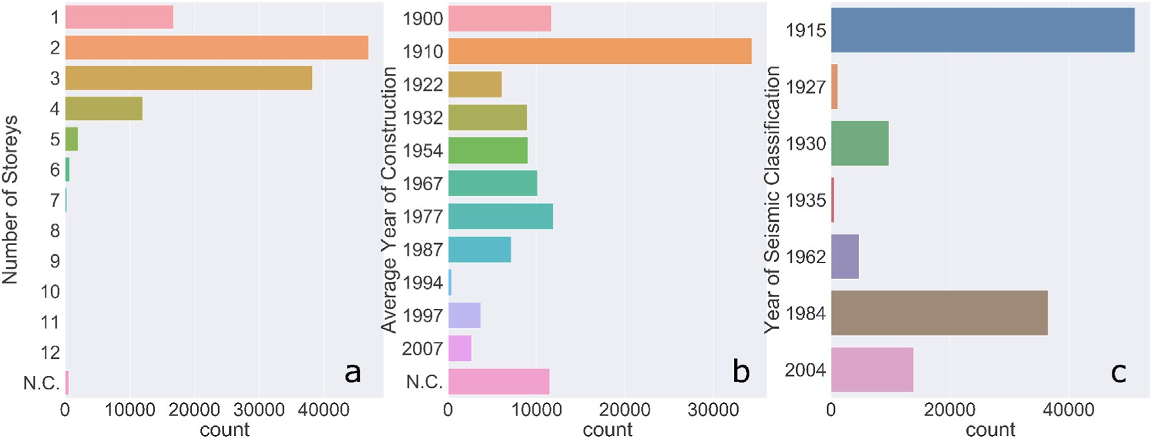

Fig. 11. Distribution of the different categories the ShakeDaDO data collection. Panel *a*: Number of Storeys; Panel *b*: Average Year of Construction; Panel *c*: Year of Seismic Classification. “N.C.” (Not compiled) implies that no information was available for that building in this category.

greater values, as can be seen from Fig. 7 (panel *f*) where the contribution of this shock (highlighted with pink dots) also extends in the north- eastern direction. Probably, for this earthquake, the source mechanism enhanced these longer periods.

* 1. *Molise 2002 data collection*

The sequence under examination consists of 2 earthquakes close in space and with the same magnitude. Fig. 8 shows which earthquakes the different points of the Da.D.O. database are associated with, for the 6 ground shaking variables.

From the MCS map (panel *a* in Fig. 8), we can see that the earthquake of October 31, 2002 has higher shaking values than the one that occurred the daylater, on November 1, 2002. Consequently, all the buildings

surveyed by Da.D.O. that are to the east and north of the two earthquakes are associated with the maximum shaking of the first earthquake. The association of the Da.D.O. points with respect to the two earthquakes in the sequence is substantially the same for the other ground motion variables.

* 1. *L*’*Aquila 2009 data collection*

The sequence under examination consists of several earthquakes. Fig. 9 shows which earthquakes the different points of the Da.D.O. database are associated with, for the 6 shaking parameters.

The points in the Da.D.O. database relating to the L’Aquila 2009 earthquake are associated mainly with the mainshock, M 6.1 of April 6, 2009. Only a few points to the north are, for the PGA and SA 0.3s maps,

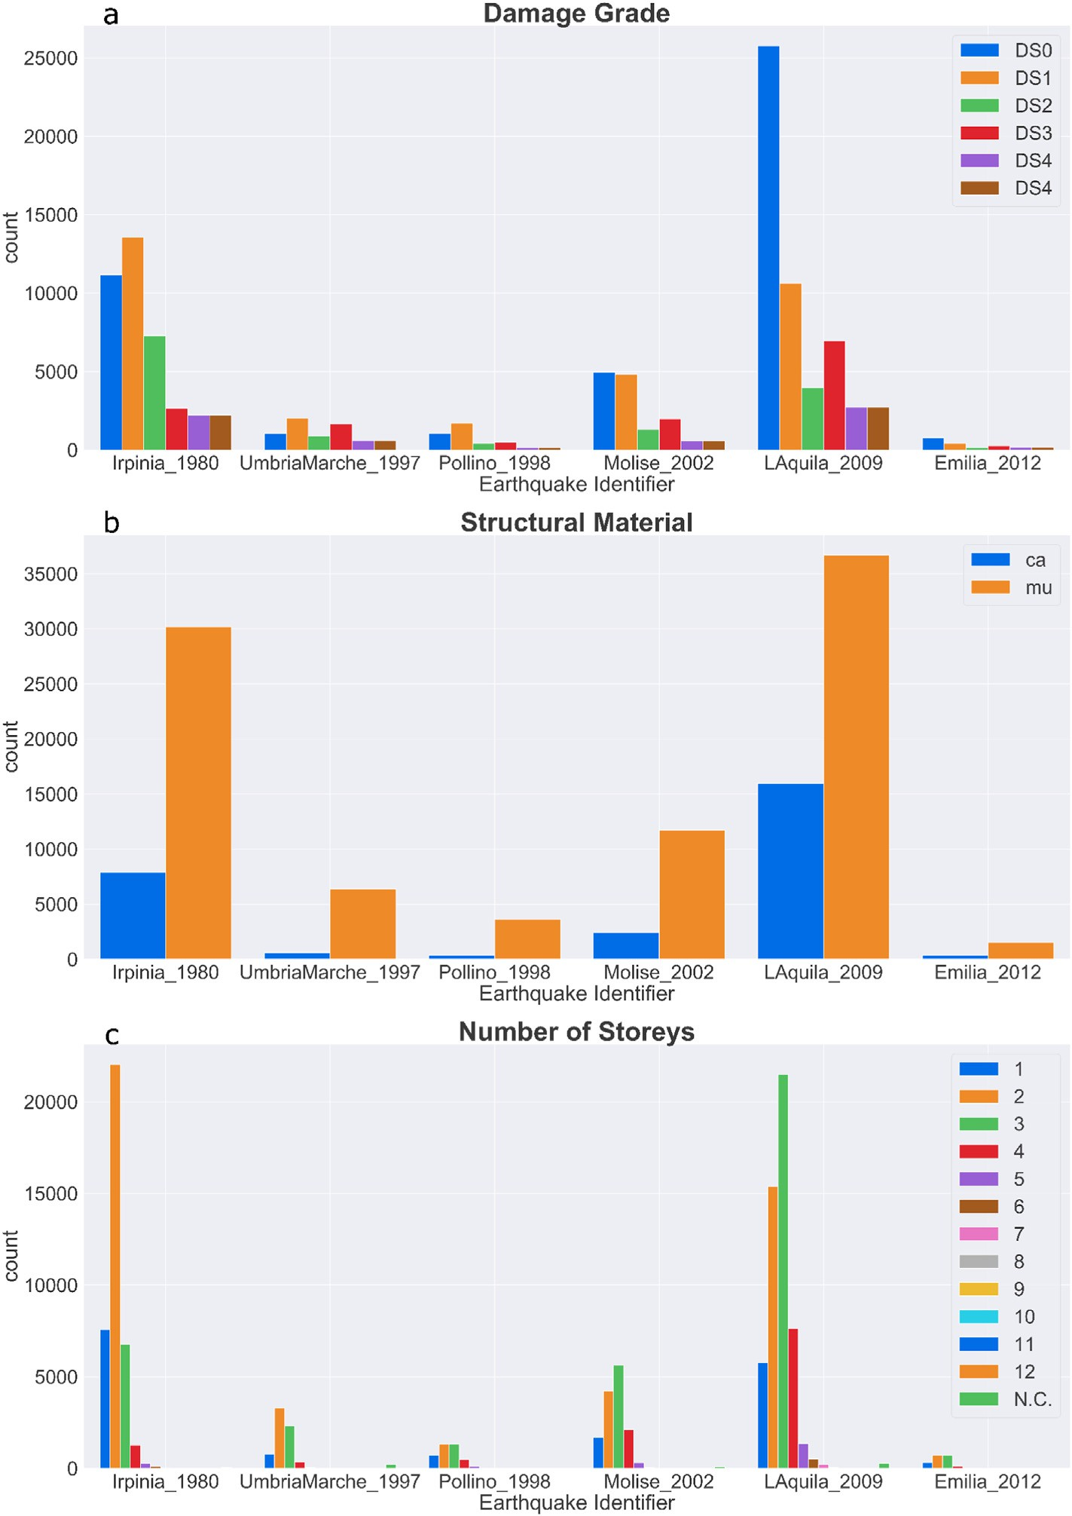

Fig. 12. Distribution of the different categories in the data collection with respect to the Earthquake Identifier. Panel *a*: Damage Grade; Panel *b*: Structural Material; Panel *c*: Number of Storeys. “N.C.” (Not compiled) implies that no information was available for that building in this category.

associated with earthquakes of magnitude M 5.2 and M 5.4 that occurred further north than the main event.

1. Final data collection

This data collection is one of the first attempt to combine engineering information collected and harmonized in Da.D.O. Dolce et al. (2019) with ground shaking data. The University of Cambridge has recently developed a platform (Spence et al., 2011) with similar purposes as ShakeDaDO. The main difference, however, is that ShakeDaDO provides data with a higher level of detail and completely disaggregated. There are six ground shaking variables: MCS scale intensity, PGA, PGV and SA at 0.3s, 1.0s and 3.0s. As noted above, the shaking was calculated using the new version of Shake- Map, with the latest seismological data and information. Each shaking value

is associated with its uncertainty. The final assembled data collection con- sists of 117,695 data points; of the resulting table each row is associated with a building. For each building, the information available is the type of structure, the number of storeys, the age of construction, and the class of damage. The year in which the municipality was classified as a seismic zone, as well as the value of Vs,30, that can be useful to get an idea of the type of soil on which the building is built, are also available in the database. We note, however, that the Vs,30 data is extracted from the Vs,30 grid used in ShakeMap, and it is not provided from direct measurements.

Figs. 10 and 11 summarises the data collection according to the building characteristics. Three-quarters of the available data come from the sum of the information of the earthquakes of Irpinia 1980 and L’Aquila 2009, while few data come from the earthquakes of Emilia 2012 and Pollino 1998 (see Fig. 10, panel *a*).

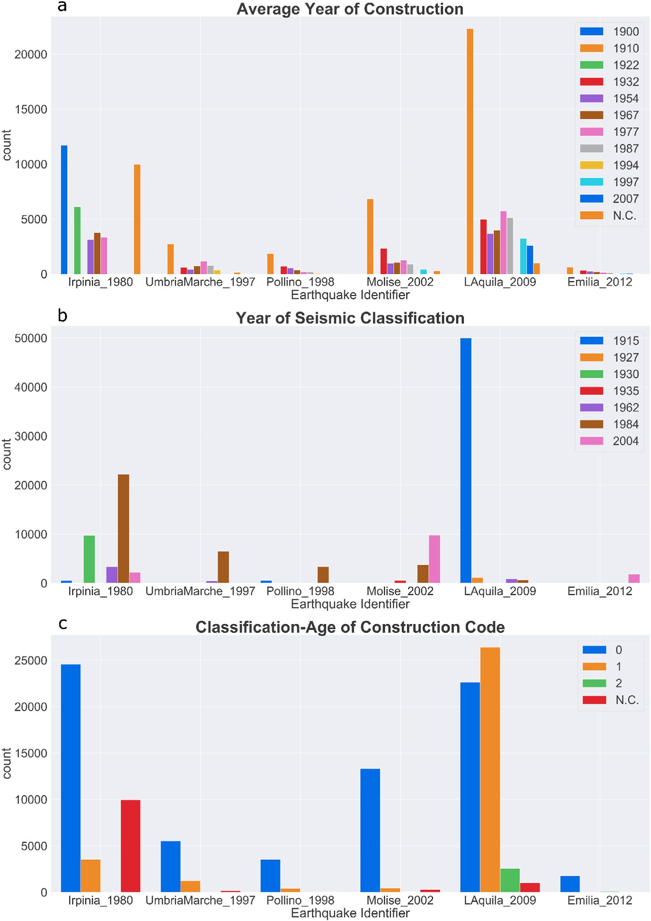

Fig. 13. Distribution of the different categories in the data collection with respect to the Earthquake Identifier. Panel *a*: Average Year of Construction; Panel *b*: Year of Seismic Classification; Panel *c*: Classification-Age of Construction Category. “N.C.” (Not compiled) implies that no information was available for that building in this category.

Concerning the type of structures, here divided only in masonry (denoted as *mu* in Figure) and reinforced concrete (denoted as *ca* in Figure), we find that three-quarters of the buildings surveyed in Da.D.O. database are of the masonry type, while only a quarter is in reinforced concrete (panel *c* of Fig. 10). The damage grades are also not equally populated. DS0 is by far the most populated, while few buildings have suffered damage falling within the DS4 and DS5 categories (panel *b* of Fig. 10). A significant portion of the buildings have just a few floors, with a considerable peak for the two or three-storey buildings (the sum of which reaches three-quarters of the total dataset). Very tall buildings, on the other hand, are not numerically relevant (panel *a* of Fig. 11). More than a third of the buildings were built before 1910, while there are about 6% constructed after 1990 (panel *b* of Fig. 11). The panel *c* in Fig. 11 shows the year of seismic classification of the municipalities. Slightly less than half of

the buildings belong to cities that have been classified since 1915. A sec- ond big slice of buildings (about 30%) belongs to municipalities that have been classified after 1984. About 12% of the buildings belong to the cities that have been classified after 2004. The combination of information on the age of construction and the year of seismic classification has defined the parameter “Classification Age” (in panel *d* in Fig. 10). 61% of the buildings were built before the municipality entered seismic classification, against 27% of buildings constructed afterwards.

Going a little more into the details of the data collection elements, Figs. 12 and 13 show how the different features are distributed in the six different seismic sequences.

Fig. 12, in panel *a*, shows the damage distribution. DS05 and DS04 are numerically relevant for the earthquakes of Irpinia 1980, Umbria Marche 1997, Molise 2002 and L’Aquila 2009, while it is nearly absent in the

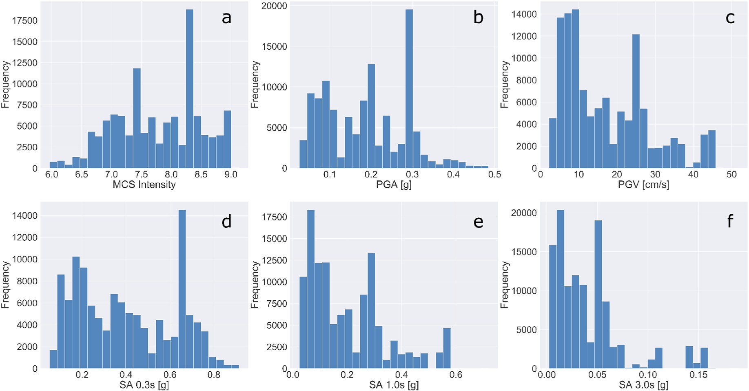

Fig. 14. Distribution of the different ground motion parameters in the data collection. Panel *a*: MCS; Panel *b*: PGA; Panel *c*: PGV; Panel *d*: SA 0.3s; Panel *e*: SA 1.0s, Panel *f*: SA 3.0s.

earthquakes of Pollino 1998 and Emilia 2012. The DS0 and DS1 grades are the most represented for all earthquakes. At the same time, class DS03 is more populated then class DS02 for the earthquakes in Umbria Marche 1997, Molise 2002 and Pollino 1998. As far as vertical structures are concerned, in all sequences and in a somewhat similar way, masonry buildings (defined as *mu* in Figure) are more abundant than reinforced concrete ones (defined as *ca*, panel *b* in Fig. 12). Finally, in panel *c* of Fig. 12, we see for all earthquakes a very high number of 2- and 3- storey buildings, while only for L’Aquila 2009 and Molise 2002, 4-storey buildings are also numerically relevant. If we analyse the features related to the age of the buildings, from Fig. 13 panel *a*, we can say that there is for the Irpinia 1980 a considerable part of the buildings that had been built before 1900. This earthquake is also the only one in which the number of buildings without this information is high. As far as the se- quences of Umbria Marche 1997, Pollino 1998 and Emilia 2012 are concerned, we observe a relatively pronounced peak of buildings built in 1910, and then very few other constructions. A similar situation also exists for the earthquakes of Molise 2002 and L’Aquila 2009. Still, in these cases, especially in the areas affected by the sequence of L’Aquila 2009, there are a significant number of buildings built in other years. The areas affected by these six sequences have a very different seismic clas- sification history (Fig. 13 panel *b*). Referring to the area affected by the Irpinia earthquake, many buildings belong to municipalities that entered the 1930 and 1984 seismic regulations. The regulations of 1930 sub- stantially affect the Irpinia area, which classified a large part of the ter- ritory after the destructive earthquake of July 23, 1930, Mw 6.7. The 1984 regulations were the first to classify a large part of the Italian re- gion, as reflected in Fig. 13, panel *b*, where all areas have some munic- ipalities classified in that year. A particular situation concerns the L’Aquila area. Most of the buildings belong to cities that were classified seismically already in 1915, following the devastating earthquake in Marsica on January 13, 1915, Mw 7. Finally, the area affected by the Emilia 2012 only entered into the last seismic regulations, dated 2004. The union of the information of panels *a* and *b* of Fig. 13, leads us to the definition of code to understand if a building was built before the seismic regulations (panel *c*, Fig. 13). As already mentioned in commenting on the previous two panels in Fig. 13, Italy has a fairly old building stock, where except for L’Aquila 2009, a large proportion of the buildings was built without the seismic regulations in place.

As regards the seismological information, for each of the 6 shaking parameters under examination, in addition to the value of the variable itself and the relative uncertainty, the distance between site and epicenter and the magnitude of the event under examination are also provided. The distance used is *RJB* when the finite source is available, and epicentral distance in other cases.

Fig. 14 shows the histograms of the ground motion variables included in the data collection. The intensity values range between a minimum of

6.0 and a maximum of 9.0 on the MCS scale. With the exclusion of two prominent peak at 7.4 and 8.3, the intensities distribute rather homo- geneously for intensities larger than 6.5. Instead, data with MCS less than

7.0 are less abundant. Looking at ground motion data, PGA has a predominant peak at 0.3 g,

a second smaller peak at 0.2 g, and it ranges between 0.02g and 0.45g. The values of PGV from 5 to 9 cm/s are all equally highly populated. A second peak is at 24 cm/s. Values between 10 cm/s and 26 cm/s are distributed over a plateau of frequencies that are comparable to each other. At the same time, values from 28 cm/s to 44 cm/s are also spread over a plateau but with a much lower frequency. SA at 0.3s has a peak at 0.7; the values of this variable range between 0.05 g and 1 g, with an almost uniform distribution. SA at 1.0s has a predominant peak at 0.07 g and a smaller peak at 0.3 g. The ranges of values are between 0.03 g and

0.6 g. SA at 3.0s has two predominant peaks 0.015g and at 0.05 g, and it ranges between 0.003 g and 0.075 g; there are some values of SA 0.3s higher, but their frequency is negligible.

Fig. 15 shows the scatterplot of the six ground motion values ac- cording to distance, differentiated according to the earthquake identifier. What we can deduce from the figure is that Pollino 1998 and Emilia 2012, which are the two least populated sequences of the data collection have a different ground motion distribution. Pollino 1998 has points that are further away as if the majority of the inhabited centres were not close to the epicentre. On the contrary, Emilia 2012 has many points very close to the epicentre, and no point is more than 80 km away. The data for the earthquake in L’Aquila 2009 and Umbria Marche 1997 are those that show a greater scatter. In fact, for the same distance, there are shaking values that cover a wide range. The data relative to Irpinia 1980 are instead those with less scatter. The greatest shaking values for all six variables are those of Irpinia 1980, followed by Emilia 2012, L’Aquila 2009 and Umbria Marche 1997.

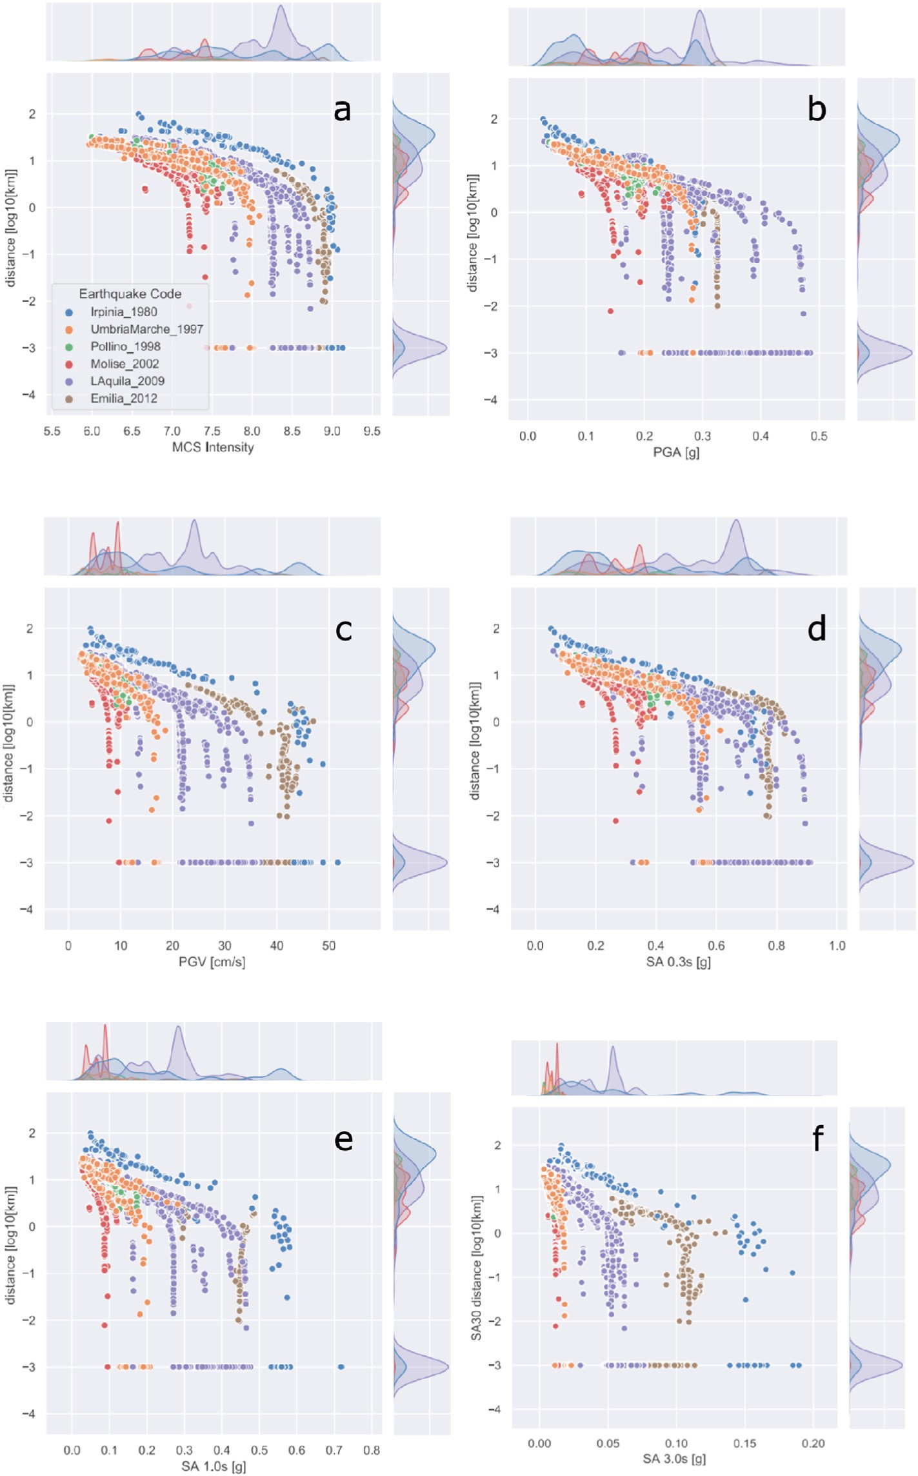

Fig. 15. Distribution of the different ground motion parameters in the data collection. Panel *a*: MCS; Panel *b*: PGA; Panel *c*: PGV; Panel *d*: SA 0.3s; Panel *e*: SA 1.0s; Panel *f*: SA 3.0s.

1. Conclusions and future applications

The ShakeDaDO data collection presented in this work combines for the first time damage data and peak ground shaking for Italy within a single structure allowing further research and applications to be under- taken by the community. In particular, the analysis of the relative de- pendencies between parameters or, possibly, deep dependencies between sets of parameters could lead to fast, euristic determinations of earth- quake impact. Overall, we believe there are multiple possible

applications. For example, there has been a significant effort since the publication of the Da.D.O. database to produce empirical fragility func- tions for the Italian building stock (e.g. DelGaudio et al., 2017, 2018; Rosti et al., 2020a, b). However, these efforts have been limited by a lack of ground shaking data for many of the events in the Da.D.O. database. We thus believe that the ShakeDaDO data collection can help greatly improve the research related to the development of empirical fragility functions in Italy. We also expect this database to be useful to test new and benchmark existing applications of new applications of Machine

Learning, which is an emerging field in seismic hazard and risk assess- ment, see for example Xie et al. (2020); Riedel et al. (2015). The ShakeDaDO data collection, derived from the information in the Da.D.O. database, will be distributed within the Da.D.O. GIS platform.

Data and resources

This paper was made utilizing the LandScan (2015) High Resolution Global Population Data Set copyrighted by UT-Battelle, LLC, operator of Oak Ridge National Laboratory under Contract No. DE-AC05-00OR22725 with the United States Department of Energy. The United States Government has certain rights in this Data Set. Neither UT-BATTELLE, LLC NOR THE UNITED STATES DEPARTMENT OF EN- ERGY, NOR ANY OF THEIR EMPLOYEES, MAKES ANY WARRANTY, EXPRESS OR IMPLIED, OR ASSUMES ANY LEGAL LIABILITY OR RE- SPONSIBILITY FOR THE ACCURACY, COMPLETENESS, OR USEFUL- NESS OF THE DATA SET.

Declaration of competing interest

The authors declare that they have no known competing financial interests or personal relationships that could have appeared to influence the work reported in this paper.

Acknowledgements

The authors would like to thank the Italian Civil Protection for the support and the discussions that improved the quality and clearness of the article. The research was supported by the European project SERA – The Seismology and Earthquake Engineering Research Infrastructure Alliance for Europe; <http://www.sera-eu.org/en/home/>; GA 730900.

Appendix A. Supplementary data

Supplementary data to this article can be found online at [https://do](https://doi.org/10.1016/j.aiig.2021.01.002) [i.org/10.1016/j.aiig.2021.01.002](https://doi.org/10.1016/j.aiig.2021.01.002).

References

[Ameri, G., Emolo, A., Pacor, F., Gallovic,̆F., 2011. Ground-motion simulations for the](http://refhub.elsevier.com/S2666-5441(21)00002-2/sref1) [1980 M 6.9 Irpinia earthquake (southern Italy) and scenario events. Bull. Seismol.](http://refhub.elsevier.com/S2666-5441(21)00002-2/sref1) [Soc. Am. 101](http://refhub.elsevier.com/S2666-5441(21)00002-2/sref1).

[Ameri, G., Gallovic,̆F., Pacor, F., 2012. Complexity of the Mw 6.3 2009 L’Aquila (central](http://refhub.elsevier.com/S2666-5441(21)00002-2/sref2) [Italy) earthquake: 2. broadband strong motion modeling. J. Geophys. Res.: Solid](http://refhub.elsevier.com/S2666-5441(21)00002-2/sref2) [Earth 117](http://refhub.elsevier.com/S2666-5441(21)00002-2/sref2).

[DelGaudio, C., DeMartino, G., DiLudovico, M., Manfredi, G., Prota, A., Ricci, P.,](http://refhub.elsevier.com/S2666-5441(21)00002-2/sref3) [Verderame, G.M., 2017. Empirical fragility curves from damage data on RC buildings](http://refhub.elsevier.com/S2666-5441(21)00002-2/sref3) [after the 2009 L’Aquila earthquake. Bull. Earthq. Eng. 15](http://refhub.elsevier.com/S2666-5441(21)00002-2/sref3).

[DelGaudio, C., Ricci, P., Verderame, G.M., 2018. A class-oriented mechanical approach](http://refhub.elsevier.com/S2666-5441(21)00002-2/sref4) [for seismic damage assessment of RC buildings subjected to the 2009 LTMAquila](http://refhub.elsevier.com/S2666-5441(21)00002-2/sref4) [earthquake. Bull. Earthq. Eng. 16](http://refhub.elsevier.com/S2666-5441(21)00002-2/sref4).

DISS, W.G., 2010. Database of Individual Seismogenic Sources (DISS), Version 3.1.1: a compilation of potential sources for earthquakes larger than M 5.5 in Italy and surrounding. [http://diss.rm.ingv.it/diss/Istituto Nazionale di Geo](http://diss.rm.ingv.it/diss/Istituto%20Nazionale%20di%20Geofisica%20e%20Vulcanologia%20-%20All%20rights%20reserved)fi[sica e](http://diss.rm.ingv.it/diss/Istituto%20Nazionale%20di%20Geofisica%20e%20Vulcanologia%20-%20All%20rights%20reserved) [Vulcanologia - All rights reserved](http://diss.rm.ingv.it/diss/Istituto%20Nazionale%20di%20Geofisica%20e%20Vulcanologia%20-%20All%20rights%20reserved).

[Dolce, M., Speranza, E., Giordano, F., Borzi, B., Bocchi, F., Conte, C., DiMeo, A.,](http://refhub.elsevier.com/S2666-5441(21)00002-2/sref6) [Faravelli, M., Pascale, V., 2019. Observed damage database of past Italian](http://refhub.elsevier.com/S2666-5441(21)00002-2/sref6) [earthquakes: the Da.D.O. WebGIS. Bollettino di Geo](http://refhub.elsevier.com/S2666-5441(21)00002-2/sref6)fi[sica Teorica. Applicata 60](http://refhub.elsevier.com/S2666-5441(21)00002-2/sref6).

[Ekstr](http://refhub.elsevier.com/S2666-5441(21)00002-2/sref7)o€[m, G., Nettles, M., Dziewonski, A.M., 2012. The global CMT project 2004-2010:](http://refhub.elsevier.com/S2666-5441(21)00002-2/sref7)

[centroid-moment tensors for 13,017 earthquakes. Phys. Earth Planet. In. 200](http://refhub.elsevier.com/S2666-5441(21)00002-2/sref7)–[201](http://refhub.elsevier.com/S2666-5441(21)00002-2/sref7).

[Galloviˇ](http://refhub.elsevier.com/S2666-5441(21)00002-2/sref8)c, [F., Pacor, F., Zahradník, J., Luzi, L., Puglia, R., D’Amico, M., 2014. Broadband](http://refhub.elsevier.com/S2666-5441(21)00002-2/sref8) [strong ground motion modeling with 1d deterministic Greens’ functions: Mw 5.5](http://refhub.elsevier.com/S2666-5441(21)00002-2/sref8) [aftershock of the 2009 L’Aquila, Italy, earthquake. In: Second European Conference](http://refhub.elsevier.com/S2666-5441(21)00002-2/sref8) [on Earthquake Engineering and Seismology, pp. 25](http://refhub.elsevier.com/S2666-5441(21)00002-2/sref8)–[29. Istanbul Aug](http://refhub.elsevier.com/S2666-5441(21)00002-2/sref8).

[Hernandez, B., Cocco, M., Cotton, F., Stramondo, S., Scotti, O., Courboulex, F.,](http://refhub.elsevier.com/S2666-5441(21)00002-2/sref9) [Campillo, M., 2004. Rupture history of the 1997 Umbria-Marche (Central Italy) main](http://refhub.elsevier.com/S2666-5441(21)00002-2/sref9) [shocks from the inversion of GPS, DInSAR and near field strong motion data. Ann.](http://refhub.elsevier.com/S2666-5441(21)00002-2/sref9) [Geophys. 47](http://refhub.elsevier.com/S2666-5441(21)00002-2/sref9).

[LandScan, 2015. High Resolution Global Population Data Set Copyrighted by UT-Battelle,](http://refhub.elsevier.com/S2666-5441(21)00002-2/sref10) [LLC, Operator of Oak Ridge National Laboratory under Contract No. DE-AC05-](http://refhub.elsevier.com/S2666-5441(21)00002-2/sref10) [00OR22725 with the. United States Department of Energy](http://refhub.elsevier.com/S2666-5441(21)00002-2/sref10).

[Luzi, L., Puglia, R., D’Amico, M., Felicetta, C., Pacor, F., Lanzano, G., Çeken, U.,](http://refhub.elsevier.com/S2666-5441(21)00002-2/sref11) [Clinton, J., Costa, G., et al., 2016. The engineering strong-motion database: a](http://refhub.elsevier.com/S2666-5441(21)00002-2/sref11) [platform to access pan-European accelerometric data. Seismol Res. Lett. 87, 987](http://refhub.elsevier.com/S2666-5441(21)00002-2/sref11)–[997](http://refhub.elsevier.com/S2666-5441(21)00002-2/sref11).

[Michelini, A., Faenza, L., Lanzano, G., Lauciani, V., Jozinov´](http://refhub.elsevier.com/S2666-5441(21)00002-2/sref12)c, [D., Puglia, R., Luzi, L., 2020.](http://refhub.elsevier.com/S2666-5441(21)00002-2/sref12)

[The new ShakeMap in Italy: progress and advances in the last 10 yr. Seismol Res. Lett.](http://refhub.elsevier.com/S2666-5441(21)00002-2/sref12) [91](http://refhub.elsevier.com/S2666-5441(21)00002-2/sref12).

[Michelini, A., Faenza, L., Lauciani, V., Malagnini, L., 2008. ShakeMap implementation in](http://refhub.elsevier.com/S2666-5441(21)00002-2/sref13) [Italy. Seismol Res. Lett. 79, 688](http://refhub.elsevier.com/S2666-5441(21)00002-2/sref13)–[697](http://refhub.elsevier.com/S2666-5441(21)00002-2/sref13).

[Paolucci, R., Mazzieri, I., Smerzini, C., 2015. Anatomy of strong ground motion: near-](http://refhub.elsevier.com/S2666-5441(21)00002-2/sref14) [source records and three-dimensional physics-based numerical simulations of the Mw](http://refhub.elsevier.com/S2666-5441(21)00002-2/sref14)

[6.0 2012 may 29 Po plain earthquake, Italy. Geophys. J. Int. 203](http://refhub.elsevier.com/S2666-5441(21)00002-2/sref14).

[Pezzo, G., Boncori, J.P.M., Tolomei, C., Salvi, S., Atzori, S., Antonioli, A., Trasatti, E.,](http://refhub.elsevier.com/S2666-5441(21)00002-2/sref15) [Novali, F., Serpelloni, E., Candela, L., Giuliani, R., 2013. Coseismic deformation and](http://refhub.elsevier.com/S2666-5441(21)00002-2/sref15) [source modeling of the May 2012 Emilia (Northern Italy) earthquakes. Seismol Res.](http://refhub.elsevier.com/S2666-5441(21)00002-2/sref15) [Lett. 84](http://refhub.elsevier.com/S2666-5441(21)00002-2/sref15).

[Pondrelli, S., 2002. European-mediterranean Regional Centroid](http://refhub.elsevier.com/S2666-5441(21)00002-2/sref16)–[Moment Tensors Catalog](http://refhub.elsevier.com/S2666-5441(21)00002-2/sref16) [(RCMT] [data Set]. Istituto Nazionale di Geo](http://refhub.elsevier.com/S2666-5441(21)00002-2/sref16)fi[sica e Vulcanologia](http://refhub.elsevier.com/S2666-5441(21)00002-2/sref16).

[Riedel, I., Gu´eguen, P., Mura, M.D., Pathier, E., Leduc, T., Chanussot, J., 2015. Seismic](http://refhub.elsevier.com/S2666-5441(21)00002-2/sref17)

[vulnerability assessment of urban environments in moderate-to-low seismic hazard](http://refhub.elsevier.com/S2666-5441(21)00002-2/sref17) [regions using association rule learning and support vector machine methods. Nat.](http://refhub.elsevier.com/S2666-5441(21)00002-2/sref17) [Hazards 76](http://refhub.elsevier.com/S2666-5441(21)00002-2/sref17).

[Rosti, A., DelGaudio, C., DiLudovico, M., Magenes, G., Penna, A., Polese, M., Prota, A.,](http://refhub.elsevier.com/S2666-5441(21)00002-2/sref18) [Ricci, P., Rota, M., Verderame, G.M., 2020a. Empirical vulnerability curves for Italian](http://refhub.elsevier.com/S2666-5441(21)00002-2/sref18) [residential buildings. Boll. Geo](http://refhub.elsevier.com/S2666-5441(21)00002-2/sref18)fi[s. Teor. Appl. 61](http://refhub.elsevier.com/S2666-5441(21)00002-2/sref18).

[Rosti, A., Rota, M., Penna, A., 2020b. Empirical Fragility Curves for Italian URM](http://refhub.elsevier.com/S2666-5441(21)00002-2/sref19) [Buildings. Bulletin of Earthquake Engineering](http://refhub.elsevier.com/S2666-5441(21)00002-2/sref19).

[Spence, R., So, E., Jenkins, S., Coburn, A., Ruffle, S., 2011. A global earthquake building](http://refhub.elsevier.com/S2666-5441(21)00002-2/sref20) [damage and casualty database. Adv. Nat. Technol. Hazards Res. 29](http://refhub.elsevier.com/S2666-5441(21)00002-2/sref20).

[Worden, C.B., Thompson, E.M., Baker, J.W., Bradley, B.A., Luco, N., Wald, D.J., 2018.](http://refhub.elsevier.com/S2666-5441(21)00002-2/sref21) [Spatial and spectral interpolation of ground-motion intensity measure observations.](http://refhub.elsevier.com/S2666-5441(21)00002-2/sref21) [Bull. Seismol. Soc. Am. 108](http://refhub.elsevier.com/S2666-5441(21)00002-2/sref21).

[Worden, C.B., Thompson, E.M., Hearne, M., Wald, D.J., 2020. ShakeMap Manual Online:](http://refhub.elsevier.com/S2666-5441(21)00002-2/sref22) [Technical Manual, User’s Guide, and Software Guide. U S Geological Survey](http://refhub.elsevier.com/S2666-5441(21)00002-2/sref22).

[Xie, Y., Sichani, M.E., Padgett, J.E., DesRoches, R., 2020. The Promise of Implementing](http://refhub.elsevier.com/S2666-5441(21)00002-2/sref23) [Machine Learning in Earthquake Engineering: A State-Of-The-Art Review.](http://refhub.elsevier.com/S2666-5441(21)00002-2/sref23)

[Earthquake Spectra](http://refhub.elsevier.com/S2666-5441(21)00002-2/sref23).